What is 32Auctions?
32Auctions is an online platform that allows businesses to host silent auctions and transit into a live event within a trusted network of participants.

In order to bid on items for the NAHSL 2020 silent auction, you must create a free 32Auctions account.

Signing up for 32Auctions

- Access 32Auctions website: https://www.32auctions.com/.

- Click Login, found in the upper right corner of the website page. This is where you will find the option to create a new account.

- On the next page, click “Create an account now.”

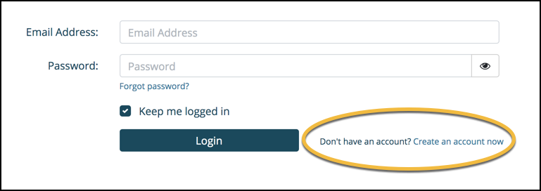

- Fill out the New User form with the appropriate information and check the accompanying boxes. Be sure to use a working, active email address. When ready, click the Create Account button. 32Auctions will automatically send you a verification email.

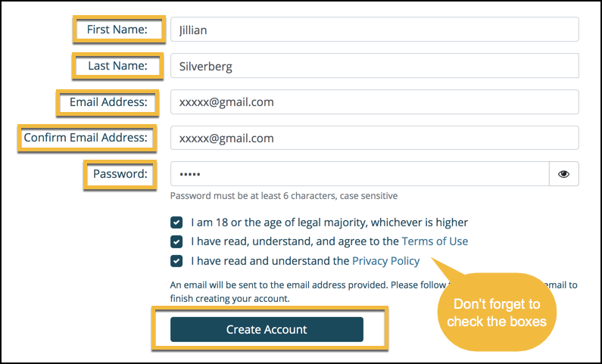

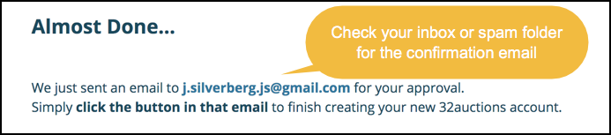

- In your email’s inbox, look for an email from 32Auctions with the subject line: “Finish creating your account…” Be sure to check your Spam inbox.

- To finish setting up your 32Auctions account, you must select the “Yes, Finish Creating My Account” button.

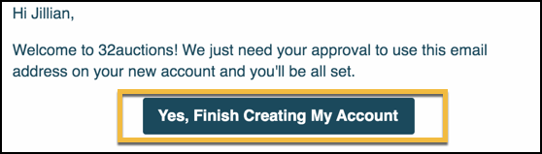

Once you have created an account, you will be able to bid on the items available in the NAHSL 2020 Silent Auction: https://www.32auctions.com/NAHSL.

